21 October 2024 Ibrahim Medical College
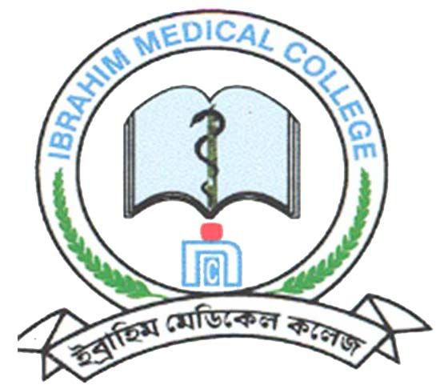

Notice

Block Posting for clinical training of the students of IM-19 (5th yr, Batch: A – F) in the following Departments/units of BIRDEM General Hospital from 19 October 2024 to 20 February 2025 has been revised as follows

Batch | 19 Oct – 07 Nov 2024 | 09 – 28 Nov 2024 | 30 Nov – 19 Dec 2024 | 21 Dec ’24 – 09 Jan 2025 | 11 – 30 January 2025 | 01 – 20 February 2025
A1: IM19: 1-10  A2: IM19: 11-20 | Medicine | Surgery | Obst./Gynae | Paediatrics | 11 – 20 January ’25  A1: EYE  A2: ENT  21 – 30 January ’25  A1: ENT  A2: EYE | 01 – 10 February ’25  A1: Orthopaedics  A2: Urology  11 – 20 February ’25  A1: Urology  A2: Orthopaedics
B1: IM19: 21-28, 30,  31  B2: IM19: 32-38,  40-42 | 19 – 28 October ’24  B1: Orthopaedics  B2: Urology  29 Oct – 07 Nov ’24  B1: Urology  B2: Orthopaedics | Medicine | Surgery | Obst./Gynae | Paediatrics | 01 – 10 February ’25  B1: EYE  B2: ENT  11 – 20 February ’25  B1: ENT  B2: EYE
C1: IM19: 44-53  C2: IM19: 55, 57-59  61-66 | 19 – 28 October ’24  C1: EYE  C2: ENT  29 Oct – 07 Nov ’24  C1: ENT  C2: EYE | 09 – 18 November ’24  C1: Orthopaedics  C2: Urology  19 – 28 November ’24  C1: Urology  C2: Orthopaedics | Medicine | Surgery | Obst./Gynae | Paediatrics
D1: IM19: 67-76  D2: IM19: 77-86 | Paediatrics | 09 – 18 November ’24  D1: EYE  D2: ENT  19 – 28 November ’24  D1: ENT  D2: EYE | 30 Nov – 09 Dec ’24  D1: Orthopaedics  D2: Urology  10 – 19 December ’24  D1: Urology  D2: Orthopaedics | Medicine | Surgery | Obst./Gynae
E1: IM19: 87-95,  114  E2: IM19: 96-97  99-106 | Obst./Gynae | Paediatrics | 30 Nov – 09 Dec ’24  E1: EYE  E2: ENT  10 – 19 December ’24  E1: ENT  E2: EYE | 21 – 30 December ’24  E1: Orthopaedics  E2: Urology  31 Dec’24 –09 Jan ’25  E1: Urology  E2: Orthopaedics | Medicine | Surgery
F1: IM19:107-109.  111-113,115-117,IM18: 06  F2: IM19: 118-120 &  IM18: 08, 18, 68, 94  IM15: 13, 83, 112, 99 | Surgery | Obst./Gynae | Paediatrics | 21 – 30 December ’24  F1: EYE  F2: ENT  31 Dec’24 –09 Jan ’25  F1: ENT  F2: EYE | 11 – 20 January ’25  F1: Orthopaedics  F2: Urology  21 – 30 January ’25  F1: Urology  F2: Orthopaedics | Medicine

Prof. Nazma Haque
Principal

No. IMC/Acad (Block posting) (IM-19, 5th yr)/2025/ Date: 20 October 2024

Copy forwarded for information & necessary action to:
- Director General, BIRDEM
- Prof. Md. Raziur Rahman, Head of the Department of Medicine, IMC & BIRDEM
- Prof. Samiron Kumar Mondal, Head of the Department of Surgery, IMC & BIRDEM
- Prof. Samsad Jahan, Head of the Dept. of Gynaecology & Obstetrics, IMC & BIRDEM
- Prof. Fauzia Mohsin, Head of the Department of Pediatrics, IMC & BIRDEM
- Prof. Purabi Rani Debnath, Head of the Dept. of Ophthalmology, IMC & BIRDEM
- Prof. Sudhangshu Shekhar Biswas, Head of the Department, Department of ENT, IMC & BIRDEM
- Prof. ATM Mowladad Chowdhury, Head of the Department, Department of Urology, IMC & BIRDEM
- Dr. Sharmistha Roy, Associate Professor of Surgery & Phase-IV Coordinator, IMC & BIRDEM
- Dr. Jonaed Hakim, Head of the Department, Department of Orthopaedics, IMC & BIRDEM
- Dr. Mohammad Tajul Islam, Registrar, Department of Medicine, IMC & BIRDEM
- Dr. Muhtarima Haque, Registrar, Department of Surgery, IMC & BIRDEM
- Dr. Shahana Sharmin, Registrar, Department of Gynaecology & Obstetrics, IMC & BIRDEM
- Dr. Mana Banik, Registrar, Department of Paediatrics, Unit- 1, IMC & BIRDEM
- Dr. Maria Siddika Mira, Registrar, Dept. of Ophthalmology, IMC & BIRDEM
- Dr. Md. Shaidul Anam, Registrar, Dept. of Otolaryngology, IMC & BIRDEM
- Dr. M. Jawad, Registrar, Department of Orthopaedics, IMC & BIRDEM
- Dr. Mohammad Abdul Aziz, Assistant Professor, Department of Urology, IMC & BIRDEM
- Mrs. Shikha, Deputy Chief Secretary, Clinical Services Dept, BIRDEM
- Mrs. Rinku Saha, Deputy Chief Secretary, Dept. of Gynaecology & Obstetrics, BIRDEM
- Mrs. Morsheda Khatun, Sr. Office Secretary, Dept. of Ophthalmology, BIRDEM
- Mr. KAM Shaiful Islam, APS, Department of Surgery, BIRDEM
- Notice Board

Prof. Nazma Haque
Principal

